Ralph Moore OLD

Student ID:001199141

D197 - Version Control

Performance Assessment: Version Control (YDM1)

***Step A Screenshot***

Below is a screenshot of the current repository graph in Gitlab after completing the steps in A:

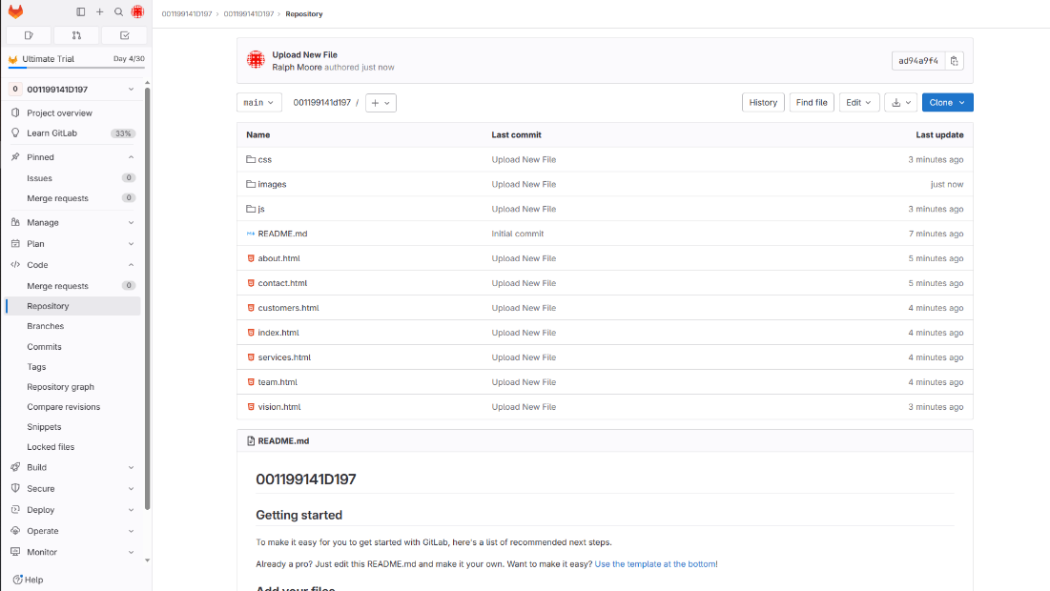

***Step B Screenshot***

Below is a screenshot of the command line action after completing the steps in B:

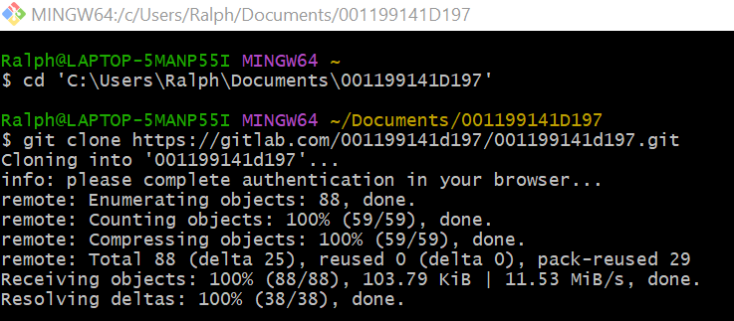

***Step C Screenshot***

Below is a screenshot for each git command for each change made to the HTML files after completing the steps in C:

**Modification 1**

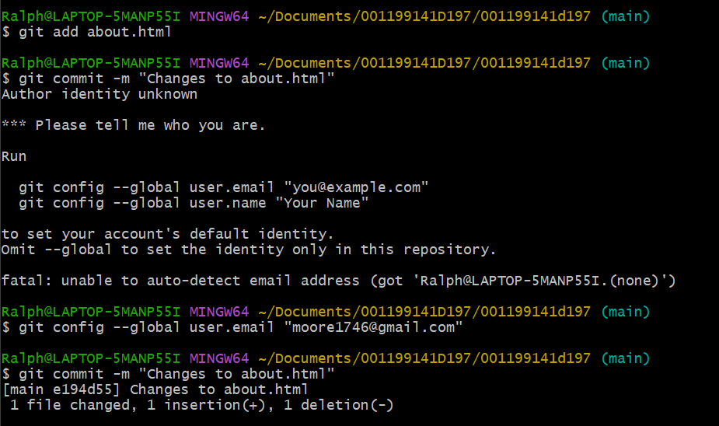

**Modification 2**

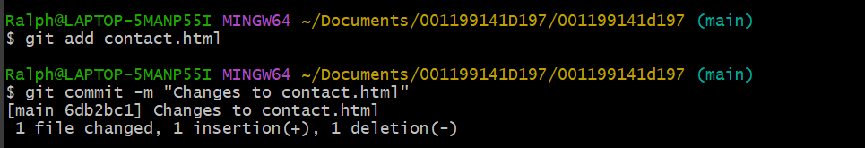

**Modification 3**

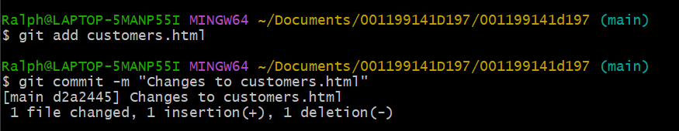

**Below is a screenshot of the command line action after completing the steps in C:**

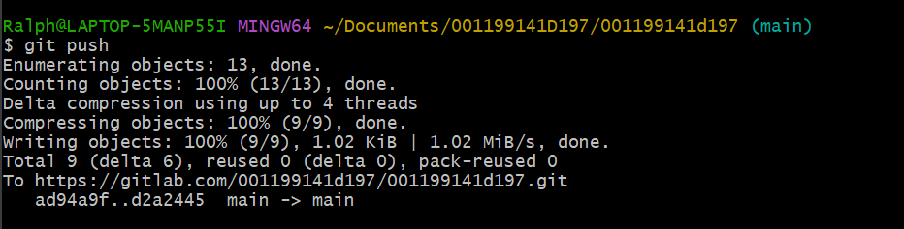

***Step D Two Screenshots***

Below is a screenshot of the command line action after completing the steps in D:

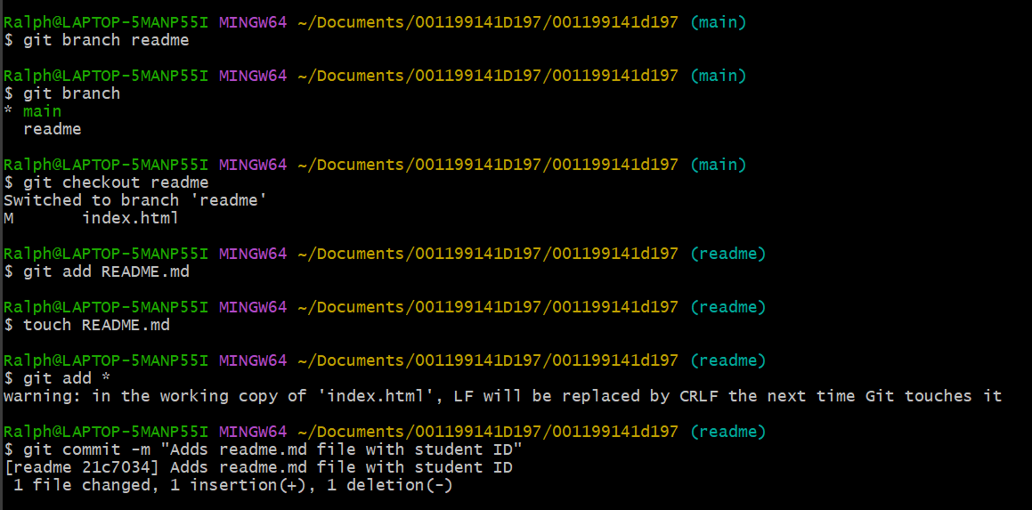

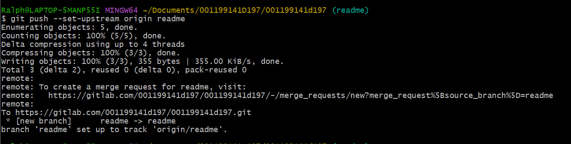

Below is a screenshot of the current repository graph in Gitlab after completing the steps in D:

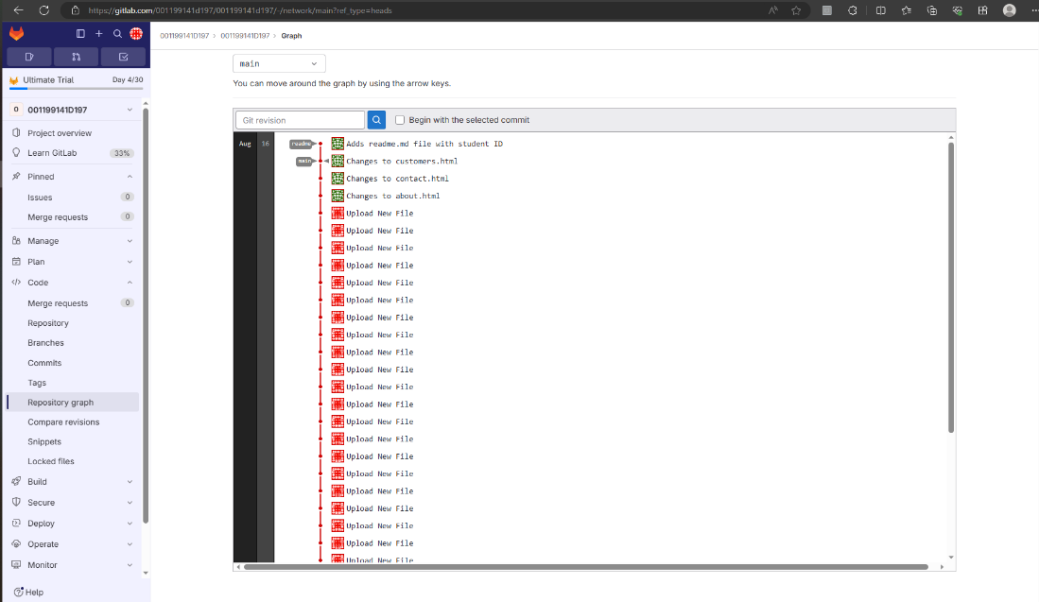

* ***Step E Two Screenshots***

Below is a screenshot that demonstrates the conflict of a merge command line action after completing the steps in E:

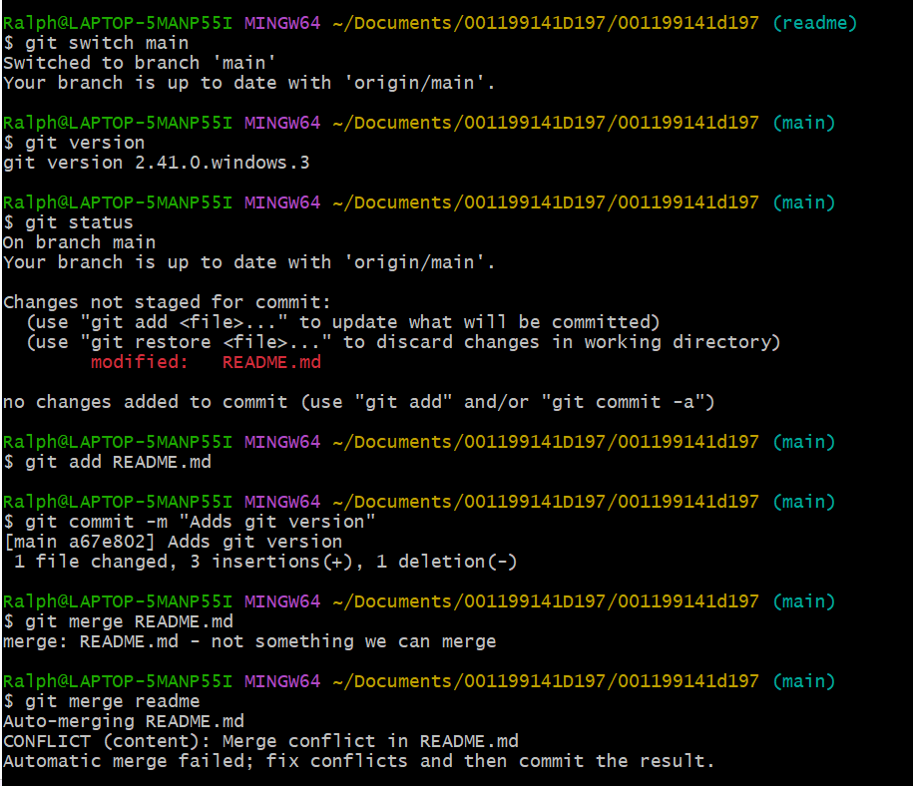

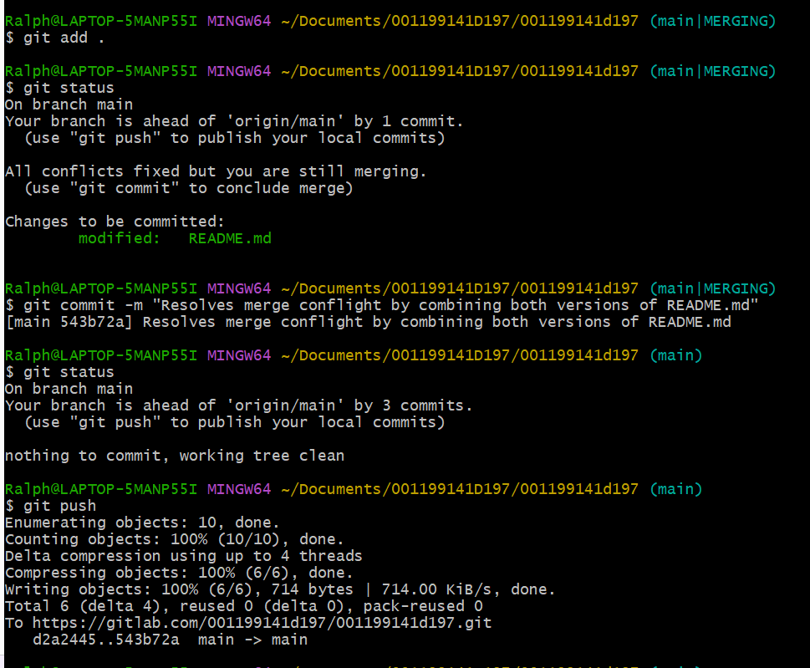

Below is a screenshot of the current repository graph in Gitlab after completing the steps in E:

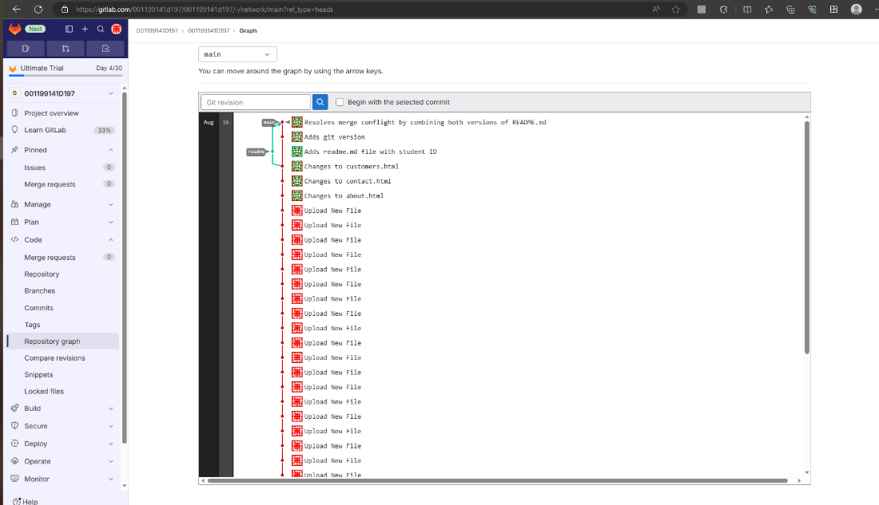

***Step F Two Screenshots***

Below is a screenshot of the command line action after completing the steps in F:

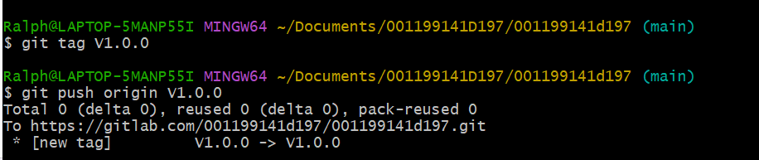

Below is a screenshot of the current repository graph in Gitlab after completing the steps in F:

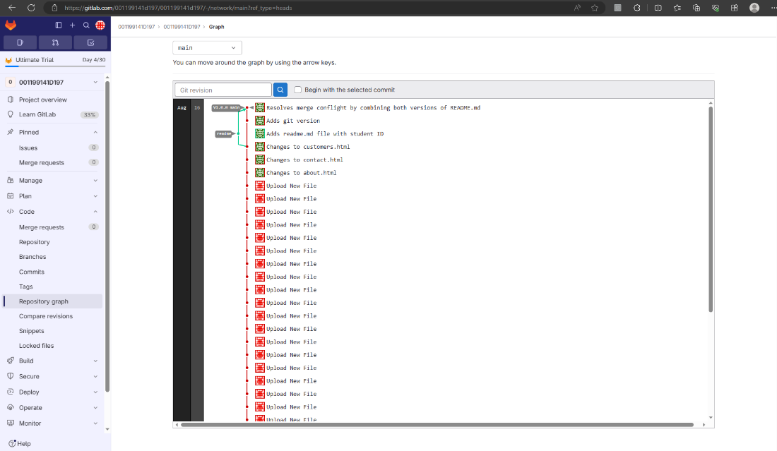

***Step G Screenshots***

Below is a screenshot of the command line action after completing the steps in G 1 & 2:

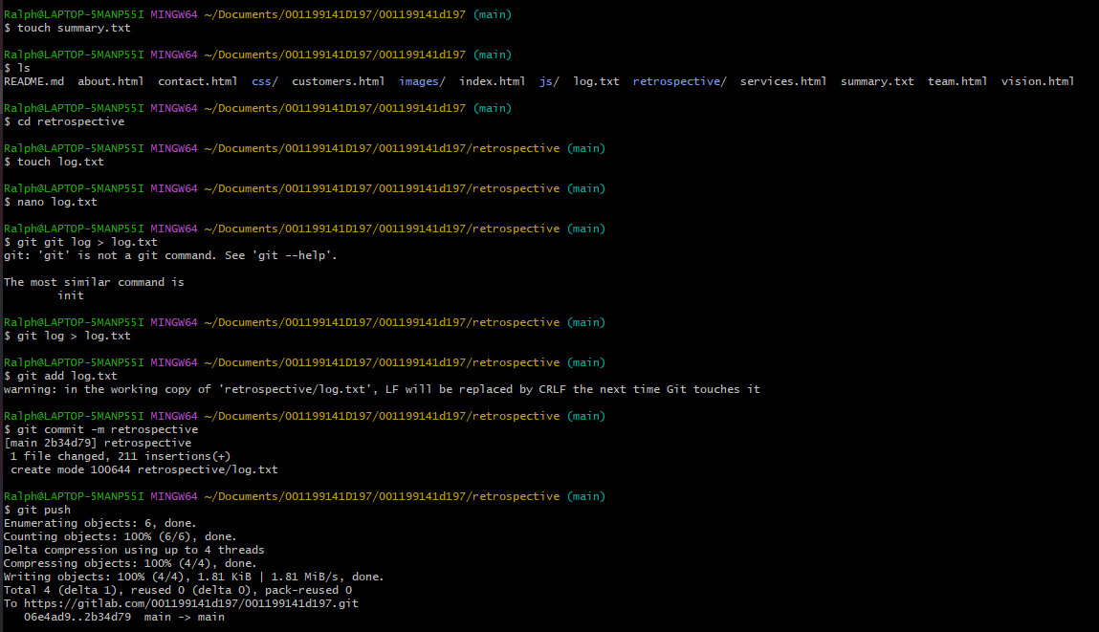

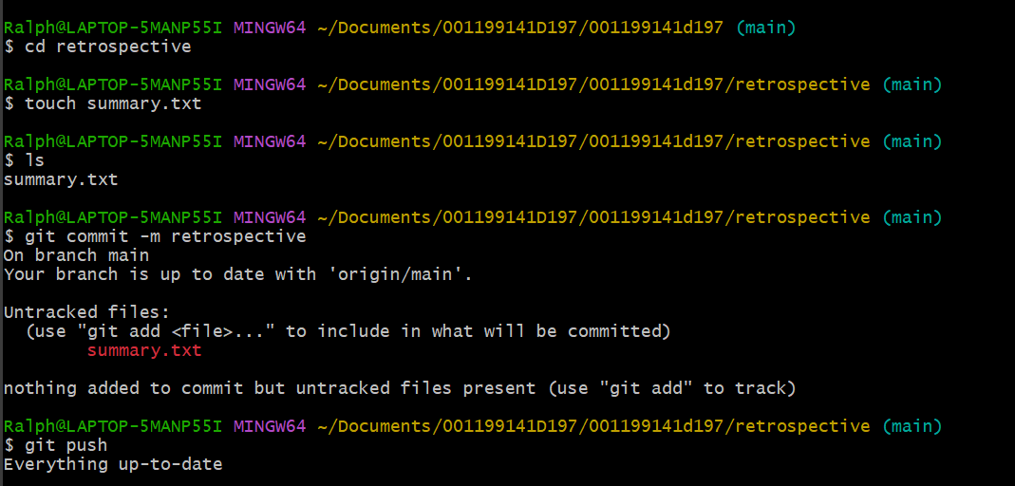

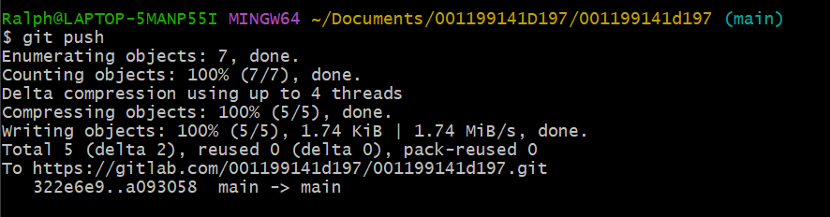

Below is a screenshot of the current repository graph in Gitlab after completing the steps in G 1 & 2: